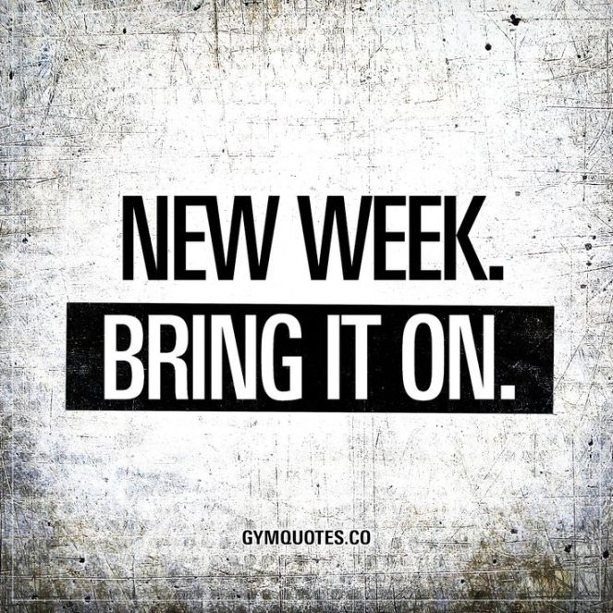
Ms. Rucker’s Online Classroom Newsletter
Hi Parents, April 13th
Hope you all had a great weekend! We miss you all at Bloom😊
UPDATES: We are placing registered students in classes for August so please complete your online registration if you haven't done so already. Remember to log on to your ParentVue account to register. If you do not have a ParentVue account set up, or have forgotten your password, please call 731-3700 and Ricki will assist you.
*I sent out an email to meet 1:1 with your child. If you have not set up an appointment, please text or email me so we can set a time up.
Please note, that if you child is participating in our Zoom sessions, there are activities that we will be discussing during the sessions. The outline of the Zoom sessions is found within the lesson plans under Monday, Wednesday, Friday at 1pm. They are bolded red for you.
READING: Start logging into Imagine Learning and beginning sessions. We will have comprehension discussions through Zoom. The discussions will be about the short stories within the lesson plans during 1 pm.
MATH: Log into either Prodigy or Zearn. Adapted Mind is a great, interactive math program to practice skills.
WRITING: Start exploring on typing.com or Dancemat, or creating your own writing worksheets on the generator.
Music/Art: Some of our assignments will be tasks that will be a part of our Zoom conversations.
Important information:
- Please communicate as much as you can.
- We have workbooks available for every Kindergartner through 8th grade that can be picked up at the student’s school they are enrolled in.
Elementary (K-5)- by 1st letter of Last Name
Location Distribution: School Bus Bay or School Parking Lot
Thursday, April 16th Students with last names that begin with A-L
Friday, April 17th Students with last names that begin with M-Z
Thank you,
Ms. Rucker, Mr. Eli and Ms. Toni

